Attachment: Application
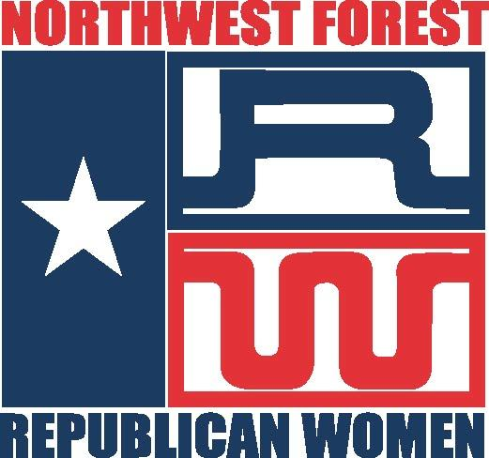

Northwest Forest Republican Women
Affiliations: National Federation of Republican Women
Texas Federation of Republican Women
Greater Houston Council of Federated Republican Women

PRISCILLA PETTY $1,000.00 SCHOLARSHIP APPLICATION

Scholarship to be awarded to a graduating Female High School Senior from Texas who has been recommended by a Primary Member of Northwest Forest Republican Women. The applicant must be accepted into an accredited bachelor’s degree Program at a College or University in the United States.

The application is available in Word format from the Scholarship Chairman
or can be filled out in ink and received by March 1, 2021.

Section A: Personal Information

Name: Date of Birth: Age:
Parents Names:
Street Address:
City: TEXAS Zip Code:
Phone Number: Email:
NWFRW Member’s Name and Email who has made your recommendation:

Section B: Graduating High School Information

Name of High School: Phone #:
School Address:
City: TEXAS Zip Code:
SAT Score: ACT Score: Graduation Date:
Grade Point Average: Grade Scale (A=?): Class Rank:
College/University: Accepted (Y/N):
Intended Major:
Section C: Awards/Honors/Scholarships
List those that most exemplify your commitment to excellence beginning in your freshman year of high school.

Name of Award | Year  Received | Presenting  Organization | Award Criteria | Amount

Section D: Academic/Student Organizations
Include only activities beginning in your freshman year of high school.

Organization | # of Years | Letters Earned | Leadership Position

Section E: Athletic Organizations
Include only activities beginning in your freshman year of high school.

Sport | # of Years Involved | Letters Earned | Leadership Position

Section F: Hobbies/Interests
You may discuss as many activities as space allows.

Section G: Civic and Political Activities and Interests
Describe any political activities in which you were involved during high school.

If you are 18, please complete the following information.
Are you a registered voter (Y/N) |  |  | Did you vote in the last election? (Y/N)
Section H: Work History
Have you held a job that required you to work a minimum of 10 hours per week?

Dates of Employment | Employer | # Hours/Week | Position

Section I: Community Activities
Describe an activity or program that illustrates your leadership ability or potential.
Detail only self-motivated, not mandated school or religious group activity.
You may discuss as many activities as space allows.

Section J: Essay Topic
“My Career Goals and Why I Should Be Considered for This Scholarship”
The essay must fit on this page.

Section K: Essay Topic
“How is the Republican Party relevant to me as a Future College Student?”
The essay must fit on this page.

Section L: Certification and Verification of Information
Please attach:
- A Letter of Reference from your NWFRW Primary Member sponsor indicating her relationship to you and any information she cares to convey to the committee;
- Two (2) Letters of Reference, each with a day and evening phone number;
- A current transcript from your high school; and
- An Applicant Photo (Optional).

Please read before signing. I certify that I am a female senior student, a legal citizen of the United States of America, and am aware that a Primary Member of Northwest Forest Republican Women is recommending me for this scholarship. I understand that if I have not submitted ALL the necessary and requested documentation and data, my application will NOT be given consideration. If I have put forth any falsehoods, I will not be considered for this Scholarship; therefore, I give Northwest Forest Republican Women and the authorized representatives the authority to verify all my information. If I am selected to receive a Priscilla Petty Scholarship, upon acceptance, I MUST submit to the organization my Social Security Number and a copy of my letter of acceptance to a four-year college or university in the United States. I agree to publicity arranged by Northwest Forest Republican Women. I understand that NWFRW will honor the scholarship recipient at the General Meeting in June.

Print Name:
Signature:
Date:

Please either email in a PDF format (not Word) the fully completed Priscilla Petty Scholarship Application and include all Certification and Verification of Information as listed in Section L in a PDF format to:
Nancy Radcliffe – radclifferesources@gmail.com or mavandermark@me.com
Or

Mail one copy of the fully completed Priscilla Petty Scholarship Application form to:
Nancy Radcliffe, 23 Sunrise Crest Trail, The Woodlands, TX 77375
Or
Mary Ann Vandermark, 9523 Needham Cross Dr, Spring, TX 77379
(Questions: 281-450-6763 - Nancy)

A letter of determination will be mailed to each applicant. Northwest Forest Republican Women congratulate each applicant for their courage, accomplishments, and initiative. We are honored by your submission and regardless of the outcome, success is within your reach.

This is not an endorsement of Northwest Forest RW, its President, or its Campaign Activities Chairman, only candidate information to help you make an informed decision and get involved with the candidate of your choice.
Pol. Ad. paid for by Northwest Forest RW PAC, Gaynell Lira, PAC Treasurer, 17807 Mellow Ridge Drive, Spring, TX 77379. Contributions are not federal tax deductible as charitable contributions. Corporate contributions are not permitted.

Solicitations made by federal candidates and officeholders are limited by federal law. The federal candidates and officeholders are soliciting only donations of up to $2500 from individuals and up to $5000 from multi-candidate political committees. They are not soliciting donations in any amount from corporations, labor organizations, national banks, federal contractors, or foreign nationals.

